ILGA-Europe Annual General Meeting Online

30-31 October 2021
Minutes

- AGM PLENARY 1: Presentation of 2021 activity reports & 2022 budget
Chair: Luca Stevenson
Minute taker: Murat Köylü
  - Approval of the Chairing Pool
Darienne made the introduction of the Chairing Pool. The voting is open for the approval of the Chairing Pool. Beryl explains the housekeeping rules and closes the vote.

The Chairing Pool is approved.
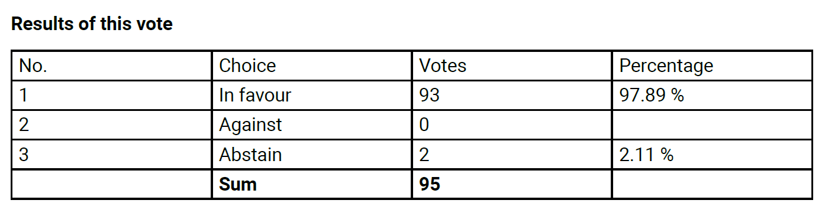

  - Approval of the agenda of the Annual General Meeting
Luca walks through the AGM agenda and gives information on how the AGM works. Luca reminds members that we are changing time (CEST to CET) during the week end. The voting is open for the approval of the agenda. Beryl closes the vote.

The AGM agenda is approved.
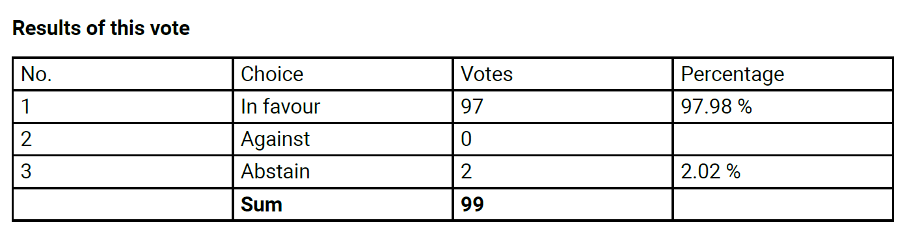
  - Report of the ILGA-Europe Executive Board on work undertaken since the 2020 Gathering Online
The Executive Board presents their report on activities and work since the previous Gathering Online.

Evelyne takes the floor and welcomes everyone. Evelyne explains that members received two different documents:
- The ILGA-Europe Activity Report
- The Executive Board Activity Report

The main objective in 2021 has been to stay steady and maintain core work to support the membership. Regranting work continues to grow to the underfunded section of the mouvement. The ‘No one left behind’ programme was a highlight: 26 grants were allocated. There was also 11 grants to support organisations facing anti-trans attacks. The number of security grants was also high (15 grants) which shows a clear increase in security needs. Other various programmes resulted in funding other organisations on various topics (communications, community building, alliance building and organisational management).

Capacity building work also continues with a focus on creating spaces among members for peer learning, coaching and financial capacity building. Another highlight was the launch of ‘The Hub’. We have started to populate The Hub with content but it will become a central tool of our capacity building work.

On the front of policy and advocacy, we observe two larger negative trends:
- Anti-trans narrative: A lot of work has happened in terms of building alliances with and knowledge amongst institutions and political actors. We also reaffirmed the position of ILGA-Europe on gender and an inclusive understanding of gender
- Hungary and Poland: A lot of work with EU institutions. LGBTI rights were on top of the political agenda. Belgian Prime Minister said the situatioın is forcing EU member states to take a stand.

In addition, the European Commission adopted its first ever LGBTI Equality Stretagy which opens up avenues for more conversations and collaboration. Strategic litigation work has continuously growed.

We continued to prioritize organizational learning with a focus on socio-economic inequalities, structural inequalities and racism, in accordance with our strategic framework – in 2021 for staff and Board, in 2022 with the wider membership.

- Report of the European representatives to the ILGA World Executive Board
Yuri takes the floor. The ILGA World Board met online this year. Four new members joined ILGA-Europe in 2021. 21 organisations are joining forces on a research project on the impact of Covid-19. Outreach and alliance building work is ongoing toward disability organisations. The ILGA World website and social media accounts were reviewed for accessibility. ILGA World plans to change how they publish legal research.
Olena takes the floor and report on the work of ILGA World financial committee and the work on the upcoming ILGA World Conference. The Executive Director left the organisation and the Board is ensuring the interim at the moment. Several new staff members just started. The team grew from 12 to 17 staff. ILGA World is also running a global internship program (15 interns on different topics).
Reports from the ILGA World Steering Committee have been shared with members by email ahead of the AGM.
- Proposal of the ILGA-Europe Executive Board on the 2022 budget
Yves takes the floor. His presentations contains two parts:
- Update of 2021 financial situation
- Presentation of 2022 budget

Refer to slides.

Members can ask questions in the dedicated workshop immediatelly after the plenary.

Luca closes the session.

- AGM PLENARY 2: Revision of the Constitution & Standing Orders
Chair: Ulrike Westerlund
Minute taker: Marta Ramos
- Presentation of amendments to the Constitution (and Q&A)
Ulrika opens the session and gives the floor to the Board. Anasastia and Soudeh present the amendments to the Constitution.
Amendments can be clustered in five categories:
- Mandatory for compliance with the Belgian Code of Companies and Associations: Amendments #4, 19, 21, 26, 31, 43, 48, 50, 51
- Cleaning the text for consistency, removing outdated references, updating language to reflect current practices: Amendments #1, 2, 7, 8, 9, 9bis, 11, 15, 20bis (which cancels 20), 22, 25, 27, 29, 36, 38, 39, 49

- Aligning the text with ILGA World provisions and practices: 10, 12, 13, 14, 15bis, 16 (completed by 16bis), 17, 24,
- Recommended by pro bono lawyer for completeness, accuracy and/or flexibility: Amendments #3, 5, 6 (completed by 6bis), 18, 28, 30 (completed by 30bis), 32, 33, 34, 35, 37, 40, 41, 42, 44, 45, 46, 47
- Related to introducing online AGM, online voting and advanced/anticipated voting: Amendments #23 (completed by 23bis), 25bis

Anasastia and Soudeh walks through each category and hilghlight the main changes. Anasastia and Soudeh ask if there are any questions or comments from members.

- Jackie asks if the new legal framework means we will have two general meetings per year. The answer is yes.
- Inge notes a typo in section C.1.a. The text should say “ILGA World”
- Soudeh gives the floor to LGBT Kommitteen to present their amendments to the Board initial proposal. The Board support this proposal.
- Jackie has a proposal: replacing “resign” by “withdraw” at section C.6. The Board support this proposal.
- On amendment 18, Jackie recalls the ILGA World has the exclusive power to decide on membership fees. Steffen agrees that this amendment should be deleted. Soudeh explains that this paragraph needs to be read as a whole – it is about brining more clarity and predictability to members. Ulrike suggest to add the work “voluntary”. The Board support this proposal.

No more questions or comments.

The consolidated version of the Constitution, including the proposals discussed and supported during this session, are submitted to the vote of members.

In order to comply with Belgian law, the procedure for the approval of changes to the Constitution should have been done in presence of a notary. Since the notary could not be there in person this week end the members are invited to unanimously appoint two people to represent them in front of the the notary to complete the procedure. The members appoint Luca and Evelyne.
- Presentation of amendments to the Standing Orders (and Q&A)
Darianne introduce the changes to the Standing Orders. They are mainly for consistency with the revised Constitution. Darienne walks through the amendments to the Standing Orders and takes questions from members.

The Board’s proposal includes replacing the Representation Advisory Committee by a Board Internal Audit. Darienne explains the rationale for the amendment. There are no questions or comments.

Krister asks why the ILGA World Steering Committees are not mentioned in the Standing Orders. Soudeh explains that the Steering Committees are managed and regulated by ILGA World, not ILGA-Europe.

Ulrike reminds members about the voting deadline and closes the session.

- AGM PLENARY 3: ILGA World & Elections
Chair: Luca Stevenson
Minute taker: Murat Köylü
- Presentation of ILGA World Conference 2022
Beryl welcomes the participants and explains the housekeeping rules.

A pre-recorded video message by the Co-Secretaries General of ILGA World is showed on screen.

Andre from ILGA World is joining this session to present the ILGA World Conference which will take place in May 2022 in Los Angeles in collaboration with the local host “It Gets Better” project. Andre explains the structure of ILGA Wolrd and the role of the regions. Andre presents the programme for the conference and the scholarship scheme.
- Election to the ILGA-Europe Executibe Board (1-year term)
Luca explains that we will screen the pre-recorded videos from the candidates. Members can then ask questions in the chat box or raise their hand to take the floor. Each candidate witll have 2 minutes to answer.

Ulrike explains why we need to elect a Board member for a 1-year mandate following the resignation of Svetlana Zakharova at half term and the fact that no reserve canddiates passed the 20% threshold during the election at the 2020 AGM. The only candidate is Natia Gvianishvili.

- Election to the ILGA-Europe Executibe Board (full term)
Ulrike thanks the outgoing members of the Executive Board:
- Darienne Flemington
- Marame Kane
- Vyacheslav Melnyk
- Svetlana Zakharova

Ulrike introduce the candidates:
- Adilet Alimkulov
- Emina Bošnjak
- Mamikon Hovsepyan
- Dakota Jones
- Tommy Petersen
- Soudeh Rad
- Penny Smith

Adilet is absent and excused due to work commitments. No questions are asked.

Luca explains the election process and reminds member about the voting deadline.
- Election to the ILGA World Women’s Steering Committee (1-year term)
Luca explains that we need to elect a representative for a 1-year term since no candidates ran during the election at the 2020 AGM. The only candidate is Angelica Polmonari.
No questions are asked.

Luca close the session.

- AGM PLENARY 4: Voting results
Chair: Ulrike Westerlund
Minute taker: Marta Ramos

The votes were closed at 10:00. Ulrike presents the results.

  - Approval of the activity report of the ILGA-Europe Executive Board
The activity report is approved.
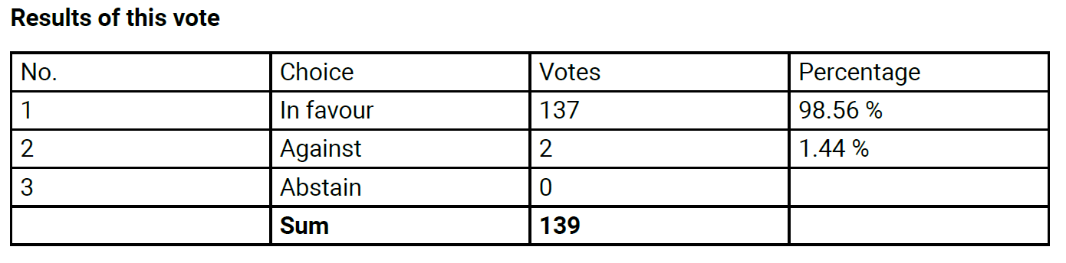
  - Approval of the activity report of the Regional Representatives toILGA World
The activity report is approved.
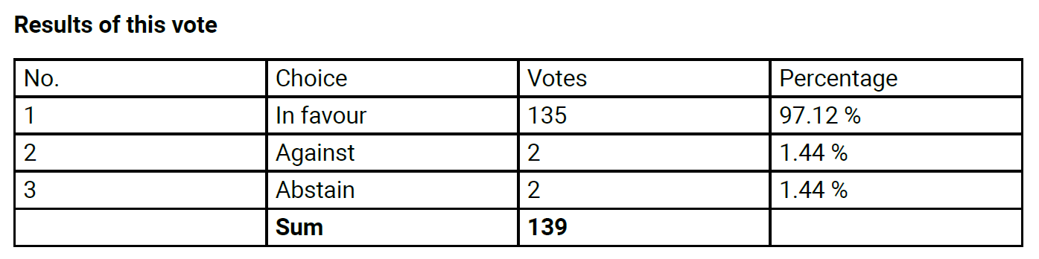
  - Approval of the ILGA-Europe 2022 budget
The budget is approved.
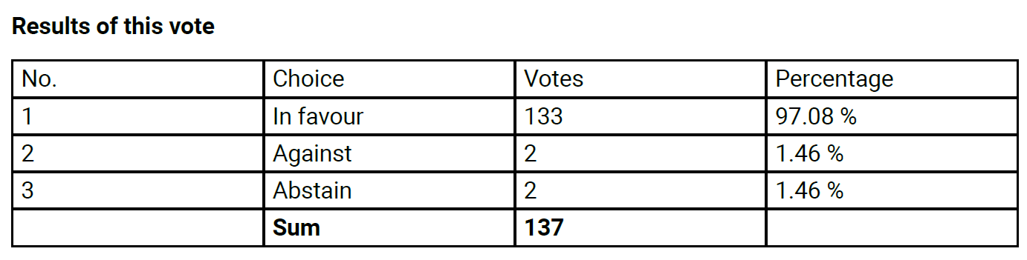

  - Approval of changes to the ILGA-Europe Constitution
The changes to the Constitution are approved.
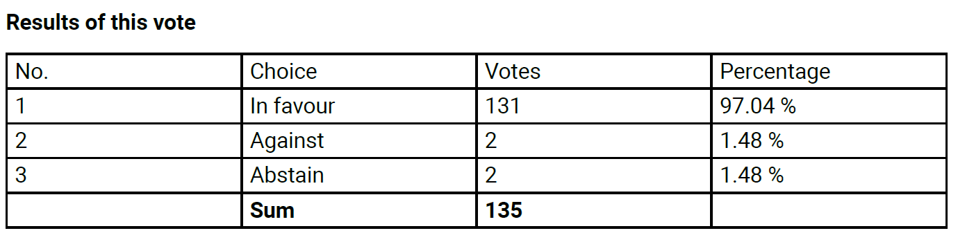
  - Approval of changes to the ILGA-Europe Standing Orders
The changes to the Standing Orders are approved.
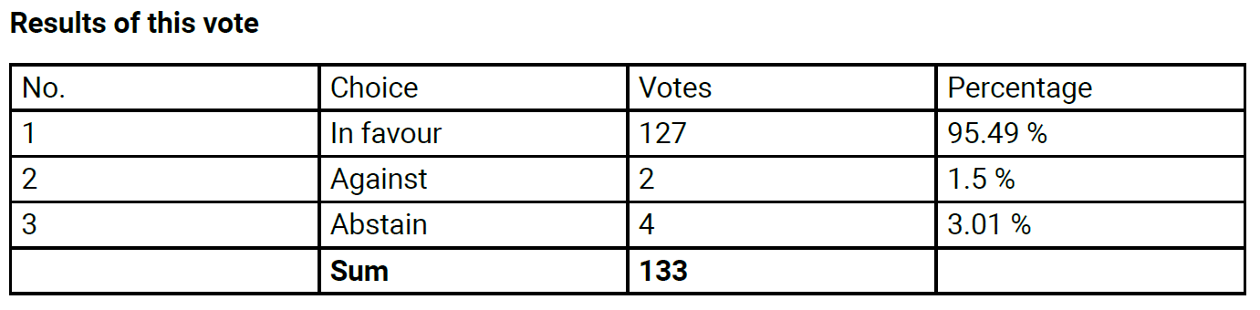

  - Election of candidates to the ILGA-Europe Executive Board (full term)
Ulrike recalls the process for the election to the Executive Board:
- Candidates are ranked by number of votes received
- All gaining at least 20% of votes remain in process
- Constitution E.1 sets 4 seats reserved for Board members identifying as women
- Non-elected candidates with 20% vote are reserves in order
136 unique votes were cast which means the 20% threshold is set at 28.
The elected candidates are Emina Bošnjak, Mamikon Hovsepyan, Tommy Petersen, Soudeh Rad and Penny Smith. Adilet Alimkulov and Dakota Jones are reserve.

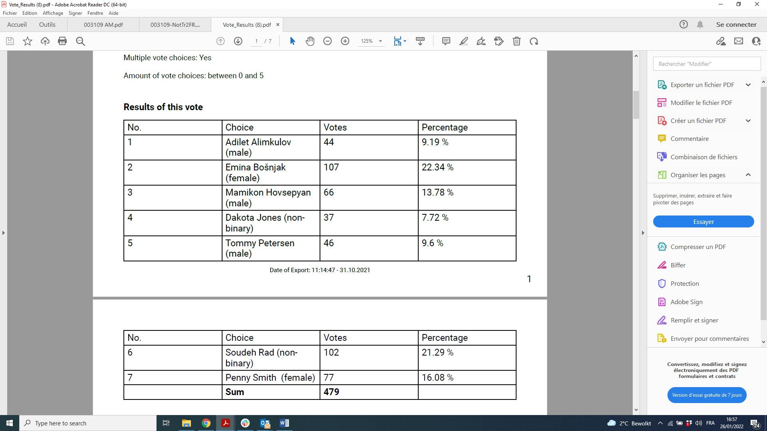

  - Election of candidate identifying as woman to the ILGA-Europe Executive Board (one-year term)
Natia Gvianishvili is elected for a 1-year term.
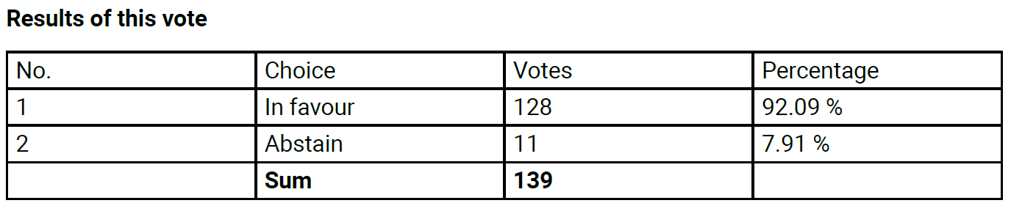

As a result, until the next Annual General Meeting in October 2022, the Executive Board is composed of:
- Yves Aerts (2021-2023)
- Emina Bošnjak (2022-2024)
- Anastasiia Danilova (2021-2023)
- Ivan Dimov (2021-2023)
- Natia Gvianishvili (2022-2023)
- Mamikon Hovsepyan (2022-2024)
- Tommy Petersen (2022-2024)
- Soudeh Rad (2022-2024)
- Penny Smith (2022-2024)
- Yuri Yoursky (2022-2024)

  - Election of candidate to the ILGA World Women's Steering Committee (one-year term)
Angelica Polmonari is elected for a 1-year term
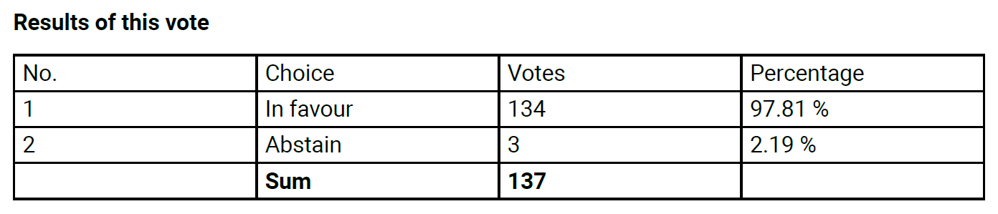

Ulrike opens the floor for final questions and comments.

Soudeh thanks members for attending. Soudeh thanks outgoing Board members and recall the attack on the Rainbow Hub in Sofia during the week end and the meaning of the “Power of Us”.
Darianne makes a goodbye speech.

Ulrika closes the AGM.

